210905212 aashish
week4
1)server:
import socket

host = socket.gethostname()
port = 12345
s = socket.socket()
s.bind((host,port))
s.listen(5)
conn, addr = s.accept()
print("got connection frm:",addr[0],'(',addr[1],')')
print("tq for connecting")
while True:
data = conn.recv(1024)
if not data: break
conn.sendall(data)
conn.close()
client:
import socket
host = socket.gethostname()
port = 12345
s = socket.socket()
s.connect((host,port))
s.sendall(b'welcome user!')
data = s.recv(1024)
s.close()
print(repr(data))
2)server:
import socket

sock = socket.socket(socket.AF_INET,socket.SOCK_DGRAM)

udp_host=socket.gethostname()
udp_port = 12345

sock.bind((udp_host,udp_port))

while True:
print ("waiting for client")
data,addr = sock.recvfrom(1024)
print("recived msg:",data.decode(),"from",addr)
sock.close()
client:
import socket

sock = socket.socket(socket.AF_INET,socket.SOCK_DGRAM)

udp_host = socket.gethostname()
udp_port = 12345

msg = "udp prog 3rd time"
print('udp target ip:',udp_host)
print('udp target port:',udp_port)

sock.sendto(msg.encode(),(udp_host,udp_port))
sock.sendto(msg.encode(),(udp_host,udp_port))
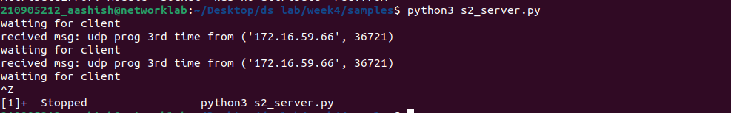
sock.close()

3)
import socket

HOST = '127.0.0.1'
PORT=2053

with socket.socket(socket.AF_INET,socket.SOCK_STREAM) as s:
s.bind((HOST,PORT))
s.listen()
conn,addr=s.accept()

with conn:
print('connected by',addr)
while True:
data = conn.recv(1024)
if data:
print("client:",data.decode())
data = input("enter msg to client:")
if not data:
break;
conn.sendall(bytearray(data,'utf-8'));
conn.close()
client:
import socket

HOST ='127.0.0.1'
PORT = 2053

with socket.socket(socket.AF_INET,socket.SOCK_STREAM) as s:
s.connect((HOST,PORT))
s.sendall(b'hello,world')
data = s.recv(1024)
print('Recived connection')
print('Server:',data.decode())

4)
#time server

import socket
import time

serversocket = socket.socket(socket.AF_INET,socket.SOCK_STREAM)

host = socket.gethostname()
port = 9991

serversocket.bind((host,port))
serversocket.listen(5)

while True:
clientsocket,addr=serversocket.accept()
print("got connection req from %s "%str(addr))
currenttime = time.ctime(time.time())+"\r\n"
clientsocket.send(currentTime.encode('ascii'))
clientsocket.close()

client:
import socket

s=socket.socket(socket.AF_INET,socket.SOCK_STREAM)

host = socket.gethostname()
port = 9991

s.connect((host,port))

tm=s.recv(1024)
print('current time from server:',tm.decode())
s.close()

5)
import socket

HOST = socket.gethostname()
PORT = 31621

s = socket.socket()
s.bind((HOST,PORT))
s.listen()
print("waiting fr incoming connections:")
conn,addr=s.accept()
print("recived connection frm:",addr[0],'(',addr[1],")\n")
name = input(str("enter ur name:"))
conn.send(name.encode())

while True:
message = input(str("Me : "))
if message =="[e]":
message="Left chat room!"
conn.send(message.encode())
print("\n")
break
conn.send(message.encode())
message = conn.recv(1024)
message = message.decode()
print(name, ":", message)

import socket

HOST = socket.gethostname()
PORT = 31621

s = socket.socket()

name=input(str("\n enter name:"))

print("trying to connect to",HOST,"(",PORT,")\n")
s.connect((HOST, PORT))
print("Connected...\n")
s.send(name.encode())
s_name = s.recv(1024)
s_name = s_name.decode()
print(s_name, "has joined the chat room\nEnter [e] to exit chat room\n")

while True:
message = s.recv(1024)
message = message.decode()
print(s_name, ":", message)
message = input(str("Me : "))
if message =="[e]":
message = "Left chat room!"
s.send(message.encode())
print("\n")
break
s.send(message.encode())

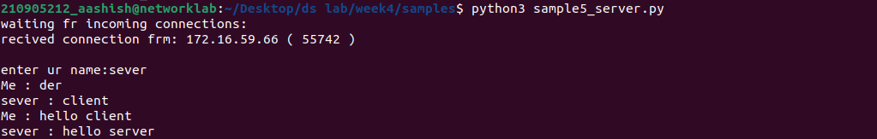
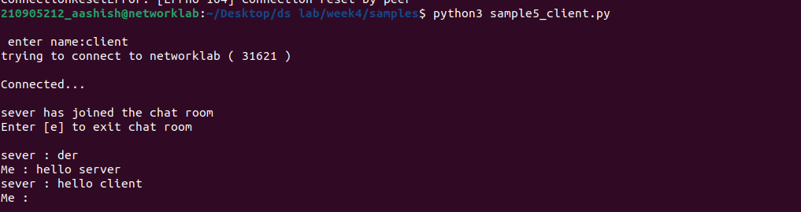

6)

import socket
import os
from _thread import *
ServerSocket = socket.socket()
host = socket.gethostname()
port = 1234
ThreadCount = 0
try:
ServerSocket.bind((host, port))
except socket.error as e:
print(str(e))
print('Waitiing for a Connection..')
ServerSocket.listen(5)

def threaded_client(connection):
connection.send(str.encode('Welcome to the Servern'))
while True:
data = connection.recv(2048)
reply = 'Server Says: ' + data.decode('utf-8')
if not data:
break
connection.sendall(str.encode(reply))
connection.close()

while True:
Client, address = ServerSocket.accept()
print('Connected to: ' + address[0] + ':' + str(address[1]))
start_new_thread(threaded_client, (Client, ))
ThreadCount += 1
print('Thread Number: ' + str(ThreadCount))
ServerSocket.close()

import socket
ClientSocket = socket.socket()
host = socket.gethostname()
port = 1234
print('Waiting for connection')
try:
ClientSocket.connect((host, port))
except socket.error as e:
print(str(e))
Response = ClientSocket.recv(1024)
while True:
Input = input('Say Something: ')
ClientSocket.send(str.encode(Input))
Response = ClientSocket.recv(1024)
print(Response.decode('utf-8'))
ClientSocket.close()

